**Simple Linear Regression – Simple Demonstration**

The maximum heart rate of a person is often said to be related to age by the equation

Max = 220 – Age

Suppose this hypothesis is to be empirically examined and 15 people of varying ages are tested for their maximum heart rate, with the results tabulated below.

|  |  |  |  |  |  |
| --- | --- | --- | --- | --- | --- |
| Case | Age | Max Rate | Case | Age | Max Rate |
| 1 | 18 | 202 | 9 | 72 | 153 |
| 2 | 23 | 186 | 10 | 19 | 199 |
| 3 | 25 | 187 | 11 | 23 | 193 |
| 4 | 35 | 180 | 12 | 42 | 174 |
| 5 | 65 | 156 | 13 | 18 | 198 |
| 6 | 54 | 169 | 14 | 39 | 183 |
| 7 | 34 | 174 | 15 | 37 | 178 |
| 8 | 56 | 172 |  |  |  |

We can implement the regression model using the following code.

|  |
| --- |
| Age=c(18, 23, 25, 35, 65, 54, 34,  56, 72, 19, 23, 42, 18, 39, 37) MaxRate=c(202,186,187,180,156,169,174,  172,153,199,193,174,198,183,178) lm(MaxRate~Age) |

The regression coefficients are presented in the following code.  
Also included is a summary of the distribution of ages (skewed towards low values).

|  |
| --- |
| Call: lm(formula = MaxRate ~ Age)  Coefficients: (Intercept)          Age     210.0485      -0.7977    > summary(Age)   Min. 1st Qu.  Median    Mean 3rd Qu.    Max.   18.00   23.00   35.00   37.33   48.00   72.00 |

The regression equation is therefore

$$\hat{y}=210.05-0.797 x$$

Where x is the observed value for age, and $\hat{y}$ is the predicted value for maximum heart rate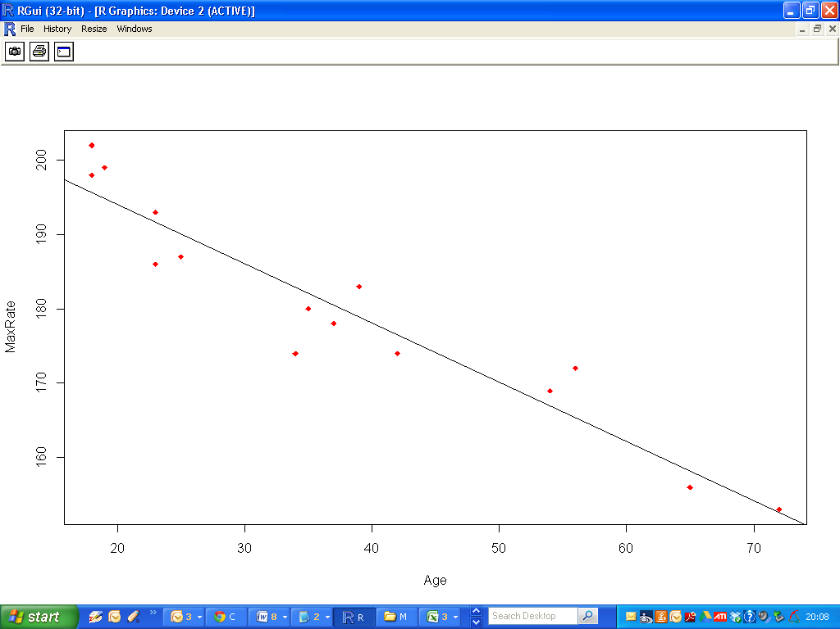

|  |
| --- |
| > confint(Fit)  2.5 % 97.5 %  (Intercept) 203.854813 216.2421034  Age -0.948872 -0.6465811 |